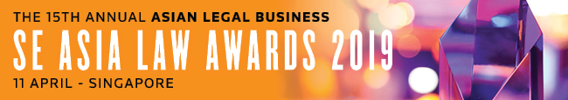

SUBMISSION FORM – FIRM CATEGORY (III)

Read the Research Methodology Summary before filling out the submission form.

Deadline for submissions – 18 January 2019 (Friday)
Send the completed forms to mary.aquino@tr.com.

For International Deal Firm of the Year and SE Asia Deal Firm of the Year, please use
Submission Form - Firm Categories (II).

For all the other firm categories, please use Submission Form - Firm Categories (I).

Save this form using the format: Category_Organisation.
SE ASIA LAW FIRM OF THE YEAR
Law firm
A. BASIC INFORMATION
Country of residence (to confirm that the nominee is based in SE Asia)
Firm size (specify: lawyers and non-lawyers)
Joiner/s in 2018 (provide names and positions)
Departure/s in 2018 (provide names and positions)
B. KEY WORK HIGHLIGHTS
KEY WORK NO. 1: (Indicate heading here)
Completion date:
Description (max. of 500 words)

KEY WORK NO. 2: (Indicate heading here)
Completion date:
Description (max. of 500 words)

KEY WORK NO. 3: (Indicate heading here)
Completion date:
Description (max. of 500 words)

KEY WORK NO. 4: (Indicate heading here)
Completion date:
Description (max. of 500 words)

KEY WORK NO. 5: (Indicate heading here)
Completion date:
Description (max. of 500 words)

KEY WORK NO. 6: (Indicate heading here)
Completion date:
Description (max. of 500 words)

KEY WORK NO. 7: (Indicate heading here)
Completion date:
Description (max. of 500 words)

KEY WORK NO. 8: (Indicate heading here)
Completion date:
Description (max. of 500 words)

KEY WORK NO. 9: (Indicate heading here)
Completion date:
Description (max. of 500 words)

KEY WORK NO. 10: (Indicate heading here)
Completion date:
Description (max. of 500 words)

C. INITIATIVES, PROJECTS & SOCIAL CONTRIBUTION
I. ORGANISATION: What were your firm's initiatives to engage, empower and develop its people? (max. of 500 words)

II. PROFESSION: What would your firm consider to be its most significant contribution to the legal community? (max. of 500 words)

III. COMMUNITY: What are the distinct features and core activities of your corporate social responsibility (CSR) program, if any? Please cite the firm's most effective and inspiring CSR activity in 2018. (max. of 500 words)

C. OTHER ACHIEVEMENTS OF NOMINEE
Description (max. of 300 words)

