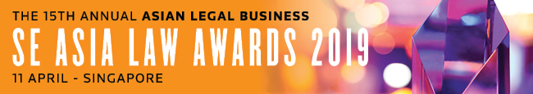

SUBMISSION FORM – IN-HOUSE TEAM CATEGORIES

Read the Research Methodology Summary before filling out the submission form.

Deadline for submissions – 18 January 2019 (Friday)
Send the completed forms to lokesh.bogati@thomsonreuters.com.

This form is for one IH category only. To submit for another category, please complete a new form.
Save this form using the format: Category_Organisation.
CHOOSE A CATEGORY HERE
Company (represented by the IH team)
A. BASIC INFORMATION
Industry
Country of residence (to confirm that the nominee is based in SE Asia)
No. of in-house counsel (based in SE Asia)
B. KEY WORK HIGHLIGHTS
KEY WORK NO. 1: (Indicate heading here)
Completion date:
Description (max. of 500 words)

KEY WORK NO. 2: (Indicate heading here)
Completion date:
Description (max. of 500 words)

KEY WORK NO. 3: (Indicate heading here)
Completion date:
Description (max. of 500 words)

C. OTHER ACHIEVEMENTS OF NOMINEE
Description (max. of 300 words)

