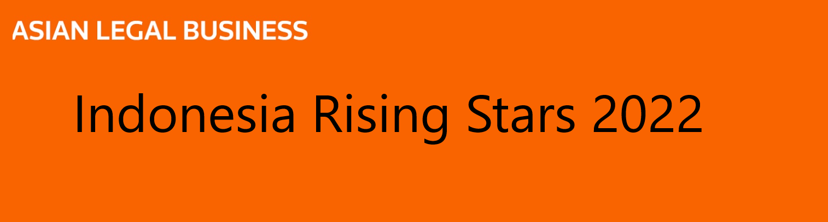
Name  Firm/Company  Age (as of January 2022)  Years of legal experience  Years in current firm/company  Current Title  Educational and bar qualification | Please do not alter this form.  Please clearly mark CONFIDENTIAL next to the details that should not be published.  To be considered for the Rising Stars India list, individuals need to be under the age of 40 as January 1, 2022. They need to be based full-time in Indonesia and can be either in private practice or working in-house.  The list will be published in the March 2022 issue of ALB Asia.
Please mail your submission to Aparna Sai at aparna.sai@thomsonreuters.com

Career Highlights
Clearly mark CONFIDENTIAL on those that are not publishable.
Please list significant career achievements
Please list the most important deals or cases (if in disputes) in career
Please list the most significant work in the last 12 months
If in private practice, please list some important clients
Please list any significant accolades received for work, such as public recognition, etc.

Recommendations (if available)
Clearly mark CONFIDENTIAL on those that are not publishable.
Comments from client(s)
(please include name, title, organisation)
Comments from managing partner, superior or other colleague
(please include name and title)

