The effect and impact of COVID-19 pandemic has caused instability to businesses across various industries. Such uncertainties have triggered the growth of different types of disputes, which have greatly influenced the way we solve them. In Asia, the judicial systems have adapted to the new “norm”. While the circumstances present many challenges, there are also considerable opportunities for those who are set to renew and reinvent.
ALB is pleased to launch our Asia’s Top 15 Litigators 2022, which will be announced in the ALB Magazine’s January/ February 2022 issue. This list celebrates top leading litigators and most impactful disputes across Asia.
Profile of cases handled, clients’ recommendations, the use of technology and innovation will be taken into consideration when making an assessment. ALB will draw information from the nominations provided, interviews, editorial resources, and market suggestions to identify the top 15 litigators in Asia.
We look forward to receiving your nominations soon.

Submissions are now open until 7 December 2021.

HOW IT WORKS
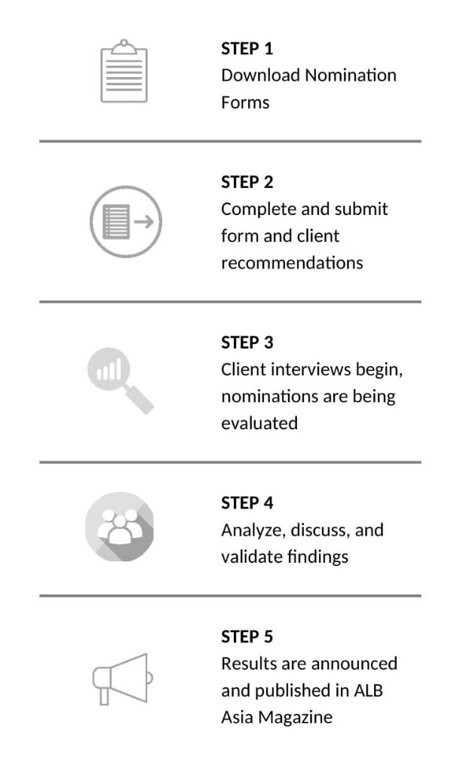
How can you submit the nomination form?
The completed nomination form may be submitted by law firms or lawyers. It provides a summary of your litigation achievements. It also presents an opportunity to demonstrate why you or your firm should be ranked in our ALB Asia’s Top 15 Litigators 2022.
You may download the nomination form here. It will guide you through all the relevant information required for our research and the information provided will be kept completely confidential.
Who can submit and when?
Submissions are open to any practicing litigators.
One firm can nominate up to TWO (2) lawyers who:
- Lawyers need to permanently be based and practice law in Asia
- Have outstanding achievements in litigation case(s) either taking place in Asia or representing an Asian client overseas from 1 Nov 2020 to 1 Nov 2021.
- Submissions from mainland China and Australia/New Zealand will not be considered for this list.
Submission deadline Tuesday, 7 December 2021, 6.00pm (Singapore time)
Our deadlines are fixed in order to allow enough time for our research team to conduct thorough verifications, retrieve recommendations and implement careful analysis on each submission
How to make a submission
Simply provide a clear summary of the following in our nomination form:
- Top 5 most significant achievements (deals, cases etc.) in candidate’s career.
- Top 5 most significant work handled in the last 12 months.
- Up to 5 of candidate’s key clients.
- Up to 5 new clients wins in the past 12 months.
- Significant accolades the candidate has received for work in the form of public recognition, awards etc.
- Any certifications, participation in bar and/or professional activities

Providing client recommendations
We also require a list of referees, whom we may interview. A referee is usually a client, although it can be anyone who has experience and knowledge of your firm in that practice area over the preceding 12 months. Providing referees allows us to gather feedback on your practice. We use these interviews to understand the views and experiences of your clients and this helps to inform our decisions.
Clients statements are referred to in the first instance and referees are only contacted should ALB require additional information regarding the matters included in the submission.
Research
We conduct our ranking research based on several factors and considerations, all of which are assessed by our research team. Our dedicated research team will review all submissions provided and carry out the necessary interviews.
Sending across your nominations and being interviewed by ALB does not guarantee a ranking. This is only part of the research process. We also consider feedback of clients and other sources as part of the ranking process.
- Online Research
  - Verify the candidate’s profile via firm’s website
  - Investigate and assess the significant litigation cases submitted by the candidate
  - Review and analyze the cases which lawyers participated in and for which judgements were pronounced in the last 12 months which are available on public channels
- Interview
Interview with clients and peers listed in the submission. This is usually done to assess client satisfaction and reputation in the industry if necessary
Details in 1 and 2 will be compiled and moved to the evaluation process.
Evaluation Process
After research and the verification of facts in the nomination forms, all documents will be sent to an independent internal judging panel for evaluation.

Evaluation Criteria
- Significant achievements (deals, cases etc.) throughout candidate’s career
- Significant cases handled in the last 12 months
- Key clients
- New clients
- Significant accolades / third-party award or recognition
- Client recommendations and comments
- Comments from managing partner or colleague
- Cases participated in and for which judgements were pronounced*
*From 1 Nov 2020 to 1 Nov 2021

The evaluation is based on the following factors: 1) Difficulty of cases; 2) Litigation strategies employed by lawyers; 3) Influence of cases and the innovative nature of cases. More details are provided below.
- Breadth: the degree to which the work involved numerous jurisdictions, legal practice areas, parties and industries;
- Complexity: the degree to which the work required crucial exercise of legal expertise, business acumen or innovative solutions;
- Impact or significance: the degree to which clients and other stakeholders, the bench and bar, an industry or the region may be affected by the case;
- Innovativeness: the degree to which the work involved the application of a new concept or creative solution, process, service, program to existing systems and processes, thus improving organizational capabilities or perhaps the use of technology to minimize the impact of the Covid-19 pandemic.

Announcement
ALB Asia’s Top 15 Litigators results will be release in January/ February 2022 issue of ALB Asia Magazine.

