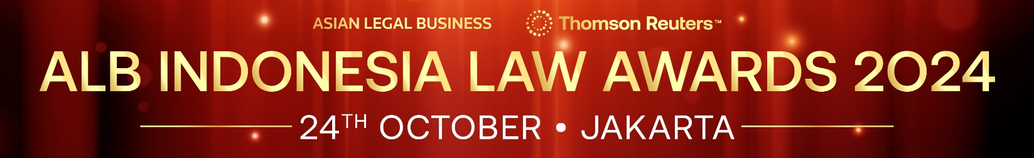

SUBMISSION FORM – DEAL CATEGORIES

Read the Research Methodology Summary before filling out the submission form.

Deadline for submissions – 2 August 2024 (Friday)
Send the completed forms to albawards@thomsonreuters.com

This form is for one deal only. To submit another deal, please complete a new form.
Save this form using the format: ALBILA2024-Category-Organisation
Example: ALBILA2024-Debt Market Deal of the Year-ABC Law Firm

Please send the submission form in Word format and do not convert it to PDF.

CHOOSE A CATEGORY HERE
Deal name
Size in USD
Announcement date
Completion date
Nominator (your firm/in-house team) | Example: Law Firm A
Role of nominator and client  (role of your firm/in-house team in the deal) | Example: Law Firm A was International counsel to Company A (Issuer) on English laws
Contact person for the deal (incl. email and phone number)
Other law firms involved | Firm role and client | Client role
Example: Law Firm B | Law Firm B was local counsel to Company A | Issuer
Other banks involved (if not listed as client above) | Bank role and client | Client role
Description (max. of 500 words)

Deal awards/recognition (only DEAL awards/recognition will be considered)

